# Transport Phenomena

For proton migration within the ceria phase to be a feasible component of the hydrogen oxidation reaction for the Ni/CGO anode, transport properties of all charge carrier species must be assessed. This section will outline the fundamental mathematics behind transport phenomena in solid solutions and electrochemical systems.

## Kinetics and Thermodynamics

For all chemical processes, including migration of atoms in a solid solution, the rate is determined as a product of a kinetic and a thermodynamic factor, as described:

|  |  |  |
| --- | --- | --- |
|  |  | 1 |

where is the activation energy and is the change in internal energy when a system changes from one state to another. This energy change of state could be a change in chemical composition or structure, but in the case of solid-state transport phenomena, the energy change is associated with the migration of a particle from one position to another. Chemical potential is a measure of the change in Gibbs free energy by an infinitesimal change in the concentration of a species. In other words, it is the tendency of a system to give particles. The chemical potential given:

|  |  |  |  |
| --- | --- | --- | --- |
|  | 2 |  | 3 |

where is the excess chemical potential, is the is an infinitesimal change in the concentration of a species, *𝛾* is the activity coefficient and is the normalised species concentration at position *x* ( is the maximum possible concentration of the particle). The illustration below shows an energy diagram as a function of particle position in space. Where ① is the energy state at the initial position and ② is the energy state at the position after a migration step in the positive *x* direction.



Fig. 1: Energy diagram for chemical process expressed as excess chemical potential.

For a particle at state 1 to migrate to state 2, it must overcome an energy barrier where . The fraction number of atoms in state 1 having energy in excess of and able to migrate to state 2 to is given as:

|  |  |  |
| --- | --- | --- |
|  |  | 4 |

And the same is true for the reverse migration. The rate of the forward migration process can therefore be given as the difference between the forward and reverse fraction numbers:

|  |  |  |
| --- | --- | --- |
|  |  | 5 |

where *v* is a constant proportional to the vibrational frequency and *ai* is the activity (*ci𝛾i*). The equilibrium constant, *K*, can therefore be described in terms of activity coefficients:

|  |  |  |
| --- | --- | --- |
|  |  | 6 |

At equilibrium, the activities of the forward and backward reactions are balanced. In the case of a reaction landscape whereby the activity of a species is a factor of its location in space, under equilibrium, . Now that the thermodynamic driving force has been defined, the kinetic factor can be considered. For a particle to migrate from one lattice position to another in an ordered structure, it must jump some distance, with a frequency, *v*. The jump frequency is the inverse of the mean transition time, 𝜏. Consider Fig. 2, where a particle is migrating left to right in the positive *x* direction. The system is under thermodynamic equilibrium so . The mean transition time can be given as:

|  |  |  |
| --- | --- | --- |
|  |  | 7 |

The diffusivity, *D*, can be introduced as the mean square distance divided by the mean transition time:

|  |  |  |
| --- | --- | --- |
|  |  | 8 |

The factor of ½ comes from an equal probability that the particle will jump in the positive or negative *x* direction. By considering Eq. 7, Eq. 8 can be modified to included the difference in activity coefficients between the ground state and the transition state:

|  |  |  |
| --- | --- | --- |
|  |  | 9 |

where is the diffusivity of the vacancy.



Fig. 2: Illustration of oxide ions diffusing through lattice sites.

|  |  |  |
| --- | --- | --- |
|  |  |  |

## Diffusion in an Ideal Solution

By neglecting interactions between atoms which contribute to the enthalpy, a model of the lattice gas system can be realised. In this way, only the configurational entropy of the system accounts mixing of the solid-solution. For a lattice structure in such a system, the chemical potential can be given as:

|  |  |  |
| --- | --- | --- |
|  |  | 10 |

where accounts for the excluded volume (lattice vacancies) and is the chemical potential of the reference state. During the course of a jump between lattice sites, the particle must occupy the transition site. At that moment in time, the lattice sites at and must remain unoccupied. Therefore, the activity coefficient for the ground state and for the transition state can be determined:

|  |  |  |
| --- | --- | --- |
|  |  | 11 |
|  |  | 12 |

By taking these new definitions for the activity coefficients, Eq. 9 can be modified to account for the concentration of vacant lattice sites:

|  |  |  |
| --- | --- | --- |
|  |  | 13 |

## Diffusion in a Concentrated Solution

When considering diffusion in a concentrated solution, the chemical potential gradient must be applied. Drift-flux is given in Eq.14 and considers the flux of particle travelling past a unit of area per unit of time, driven by some potential gradient.

|  |  |  |
| --- | --- | --- |
|  |  | 14 |

where is the flux, is the mobility, is the concentration and is the potential gradient. Flux in one dimension can be given as the rate of migration derived by the area:

|  |  |  |
| --- | --- | --- |
|  |  | 15 |

where is the unit vector in the positive *x* direction and *A* is the area. when a particle is migrating from *x* to *x+*, the following assumption can be made:

|  |  |  |  |
| --- | --- | --- | --- |
|  |  |  | 16 |

where is half of the jump distance (half of the distance between lattice sites) and *µ*(*x*) is the chemical potential at position *x*. Thus, , and Eq. 7 can be redefined:

|  |  |  |
| --- | --- | --- |
|  |  | 17 |

The mean transition time can be incomputerate into Eq. 5 by using the definition . To account for migration in the positive *x* direction only, a factor of ½ is included:

|  |  |  |
| --- | --- | --- |
|  |  | 18 |

where is the activity at the initial state and is the activity of the final migration state. The barrierless mean transition time can be included by expanding Eq. 7, the rate can be expanded giving the chemical potentials as a function of position:

|  |  |  |
| --- | --- | --- |
|  |  | 19 |

where . Thus, the flux in the positive direction can be determined by including the area term and linearizing the equation:

|  |  |  |
| --- | --- | --- |
|  |  | 20 |

where and . Using the Einstein relation and the volume definition , the flux can be given in terms diffusivity and chemical potential:

|  |  |  |
| --- | --- | --- |
|  |  | 21 |

## Fick’s First Law

Diffusion describes the spread of particles through a random walk driven by decreasing the chemical potential difference across the system. Although there are many ways to derive Fick’s Fist Law, this method is in keeping with the previous section and is a good foundation to go on to discuss more complicated models of diffusion in lattice structures.

Under thermodynamic equilibrium (dilute solution) the chemical potential gradient can be given as:

|  |  |  |
| --- | --- | --- |
|  |  | 22 |

By using this definition of chemical potential gradient in Eq. 21 the result is yields Fick’s first law of diffusion:

|  |  |  |
| --- | --- | --- |
|  |  | 23 |

This equation is fundamental for characterising the transport properties of isotopically labelled ions under thermodynamic equilibrium. The final part of this section considers the diffusion length of particles migrating through an isotropic media. For random walk in three-dimensions, a particle travels an average of after *n* steps of jump distance in the *x* direction. The penetration depth (*δ*) of the diffusing particle is a dynamical length scale which increases with time. This length is the distance travelled from to equilibrium . Therefore, after time *t*, *n* will be equal to 𝜏*t* and so *δ* is given as:

|  |  |  |  |
| --- | --- | --- | --- |
|  | *24* |  | 25 |

where the factor of 1/6 represents the possibility of migration in three dimensions. The dynamical length scale is commonly rounded to and is used heavily in mathematical analysis of diffusion profiles which will be discussed in more detail later in this report.

## Chemical Diffusion

Fick’s first law of diffusion was derived for a dilute system where the system is under thermodynamic equilibrium . However, when diffusion occurs down a chemical potential gradient, the thermodynamic factor must be considered. Chemical diffusion may occur in the hydration of an oxide material, where each migration step is associated with a change in enthalpy. In some cases, a species in a solid-solution may diffuse up a concentration gradient in order to lower the total enthalpy of the system, this is known as uphill diffusion.

By recalling the equation for flux under a chemical potential gradient, the concentration gradient can be separated leaving a thermodynamic function which is dependent on the enthalpy change with an infinitesimal change in concentration. The flux is therefore given as (full derivation in appendix):

|  |  |  |
| --- | --- | --- |
|  |  | 26 |

This brings about a new type of diffusion coefficient, chemical diffusivity (*Dδ*):

|  |  |  |
| --- | --- | --- |
|  |  | 27 |

Unlike the self-diffusion coefficient, chemical diffusivity considers the enthalpy change associated with a migration process. When a migration process occurs under thermodynamic equilibrium, is equal to *D*.

# The Conservation Equation

The differential form of the conservation equation, better known as Fick’s Second Law, can be derived in several ways. The derivation illustrated in this section models a flux travelling through a controlled volume (CV). Conservation of mass or energy may be expressed by simple mathematical balances of arbitrary particles over a CV. By taking the number of particles and volume inside the CV to be denoted by # and *Vm*, respectively, the concentration can therefore be expressed as:

|  |  |  |
| --- | --- | --- |
|  |  |  |

The integral form of the conservation equation initially states that the rate of change in *c* is zero if the rate at which # “leaks out” is equal to the rate of creation of #:

|  |  |  |
| --- | --- | --- |
|  |  |  |

where is the unit normal, *A* is the area of the CV and *BV* is the production rate density. These two effects are illustrated in Fig. 3, where the “leaking” of # is expressed as the negative of the area integral of the flux entering the CV normal to the surface. And where *B­V* describes a chemical reaction which creates # inside the CV.



Fig. : Illustration of flux through a controlled volume.

The divergence theorem states that the surface integral of the flux through a closed surface is equal to the volume integral of the divergence over the region inside the surface (Eq.34).

|  |  |  |
| --- | --- | --- |
|  |  |  |

Therefore, the following changes can be made to Eq. 29:

|  |  |  |
| --- | --- | --- |
|  |  |  |

Now that all elements of the equation are volume integrals, the time derivative may become a partial derivative and move inside of the volume integral operator:

|  |  |  |
| --- | --- | --- |
|  |  |  |

The differential form of the conservation equation is given by using the mean-value theorem to eliminate the volume element:

|  |  |  |
| --- | --- | --- |
|  |  |  |

In a system where *BV* is equal to zero, substituting Fick’s first law of diffusion for for a diffusing flux in a isotropic medium gives the differential form of the conservation equation, otherwise known as Fick’s Second Law:

|  |  |  |
| --- | --- | --- |
|  |  |  |

This equation states that the concentration of a diffusing species is a function of location and time. In three-dimensional space, Fick’s second law can be expressed as:

|  |  |  |
| --- | --- | --- |
|  |  |  |

where is the Laplacian operator. For particles diffusing through an anisotropic media, such as a chemical potential gradient (Eq.27), Fick’s second law must be modified to account for the non-ideal thermodynamic properties of a concentrated solution. The diffusion coefficient becomes a function of concentration and therefore is expressed as:

|  |  |  |
| --- | --- | --- |
|  |  |  |

## Linear Diffusion Analysis

A linear diffusion concentration profile may revel several useful pieces of information about the transport and catalytic properties of a material. This section will describe the mathematical origin behind the distinctive shape of a concentration profile and how it can be analysed to satisfy Fick’s second law. Fitting the linear diffusion concentration profile of a tracer particle yields two coefficients, the tracer self-diffusivity (*D\**) and the tracer exchange coefficient (*k\**). With respect to the diffusivity, a modification needs to be made to the self-diffusion coefficient given in **Error! Reference source not found.**. To account for the deviation from randomness of migration steps, a correlation factor (*f*) is used:

|  |  |  |
| --- | --- | --- |
|  |  | 37 |

The correlation factor is only necessary for vacancy diffusion systems, and for a fluorite structured material *f* is given as 0.65.41,42 The figure below is an example of a concentration profile for tracer particles diffusing into the media (sorption).

Fig. : Linear diffusion concentration profile.

At the surface of the media (*x=0*), the concentration is proportional to the flux of tracer particles migrating from the reservoir to the surface, and from the surface into the bulk of the media. The expression for the surface concentration is given as:

|  |  |  |
| --- | --- | --- |
|  |  | 38 |

For a dilute system to maintain thermodynamic equilibrium, there must be an equal and opposite loss of particles leaving the media as particles entering the media.43 This boundary condition has already been described as and defines the rate of exchange of species *i* at *x=0*. Tracer function can be given as:

|  |  |  |
| --- | --- | --- |
|  |  | 39 |

where [*i*] is the concentration of species *i* at the surface. For simplicity, the constant flux injection will be ignored by giving the initial and boundary conditions for the sorption problem as:

|  |  |  |  |  |
| --- | --- | --- | --- | --- |
|  |  |  |  |  |
|  |  |  |  |  |
|  |  |  |  |  |

The shape of the linear diffusing profile is distinctive and can be derived from Fick’s second law of diffusion (Eq. 34). By normalising the concentration at the surface, the sorption profile (Fig. 5) can be analysed, where ξ is a dimensionless function for distance, which can be found through dimensional analysis, and is the normalized dimensionless function for concentration . The penetration depth is defined as the distance at which . To find ξ, *x* is divided by the dynamical length scale (Eq.25) to become unitless, as expressed:

|  |  |  |
| --- | --- | --- |
|  |  |  |

Fig. : Sorption profile example.

To determine the function , Fick’s second law of diffusion can be expressed as dimensionless functions by substituting Eq.46 and Eq.47 into the partial differential equation (full derivation in appendix):

|  |  |  |  |  |  |
| --- | --- | --- | --- | --- | --- |
|  | |  |  | |  |
|  |  | | |  | |

By using an integrating factor , the function *F* is found:

|  |  |  |
| --- | --- | --- |
|  |  |  |

where the constant *A* can be evaluated to be as proven by Gaus.44,45 By imposing the condition :

|  |  |  |
| --- | --- | --- |
|  |  |  |

This is better known as the *complimentary error function* (*erfc*) and describes the concentration profile of the sorption system. Therefore, the final solution to the sorption problem is:

|  |  |  |
| --- | --- | --- |
|  |  |  |

For a system where tracer particles are desorbing from the bulk at the surface of the media, the initial condition and boundary conditions for the concentration profile are given as:

|  |  |  |  |  |  |
| --- | --- | --- | --- | --- | --- |
|  |  |  |  |  |  |
|  |  |  |  |  |  |
|  |  |  |  |  |  |

Thus, the final solution is expressed using the *error function* (*erf*):

|  |  |  |
| --- | --- | --- |
|  |  |  |

# Drift and Conductivity

Although there are many electrochemical processes occurring under SOFC operation, characterising the diffusion coefficient of charge carriers in ionic conducting materials is important in evaluating its performance. This section will discuss how the diffusion coefficient can be used to evaluate the electrochemical performance of a system by deriving the Nernst-Plank and Nernst-Einstein equations.

Mass transport driven by an external driving force yielding a net flux of particles is known as drift flux. An electrochemical potential () is defined as:

|  |  |  |
| --- | --- | --- |
|  |  |  |

where *q* is the product of the valence of ionic species and the elementary charge (units *C*), and is the electric potential (units *V*). Drift flux under an electrochemical potential gradient means that charged particle transport is influenced by both a chemical potential gradient and an electric field. Drift flux can be given as:

|  |  |  |
| --- | --- | --- |
|  |  |  |

where *c* is the concentration and is the drift velocity of charged particles. The drift velocity function can be expressed as:

|  |  |  |
| --- | --- | --- |
|  |  |  |

where *M* is the mobility (*m2 V-1 s-1*) of a charged particle.

The drift flux for a system of charged particles influenced by an electrochemical potential is expressed as:

|  |  |  |
| --- | --- | --- |
|  |  |  |

Using the definition of chemical potential in a dilute system (under thermodynamic equilibrium), the drift flux can be redefined as:

|  |  |  |
| --- | --- | --- |
|  |  |  |

where the concentration (*c*)is constant throughout the media. The drift flux function can now be used in Fick’s second law of diffusion giving the Nernst-Plank equation:

|  |  |  |
| --- | --- | --- |
|  |  |  |

It is important to note that this equation assumes a static electromagnetic condition and that the fluid velocity is zero so only charged particles are mobile. The next stage is to calculate ionic conductivity. For a system under an electric field potential, the current density (*i, A m-2*) can be expressed as:

|  |  |  |
| --- | --- | --- |
|  |  |  |

Conductivity can therefore be obtained by rearranging Ohm’s law (full derivation in appendix):

|  |  |  |
| --- | --- | --- |
|  |  |  |

For a lattice structured ion conductor, *c* can be found as the number of charge carriers per unit cell (*n*) divided by the unit cell volume (*Vm*).

Transport models in electrochemical systems are often made more complex when there are multiple charge carriers contributing to the total conductivity. In such a system, the migrational transport number (*ti*) represents the relative contribution of a charge carrier species *i* to the total conductivity of the system:

|  |  |  |
| --- | --- | --- |
|  |  |  |

# Experimental Techniques

## Isothermal Isotopic Exchange

Isothermal isotopic exchanges coupled with secondary ion mass spectrometry (IEDP) is a technique developed to yield the tracer self-diffusion coefficient () and the tracer exchange coefficient () of species diffusing through a dense material.49–51 The most common experimentation for SOFC research is performed tracing D (2H) or 18O, or in some cases both isotopes simultaneously.52 The first stage of the exchange is a pre-anneal in natural isotopic abundance gas (Dry exchange: 16O2 and Wet exchange: H216O) for at least ten times the duration of the second stage. The purpose of this stage is to equilibrate the sample’s isotopic composition by heating the sample in a gas of known composition. This also ensures the chemical potential gradient across the area of interest is negligible, as chemical diffusion of an isotope has a different thermodynamic driving force to tracer diffusion of an equilibrated system.53

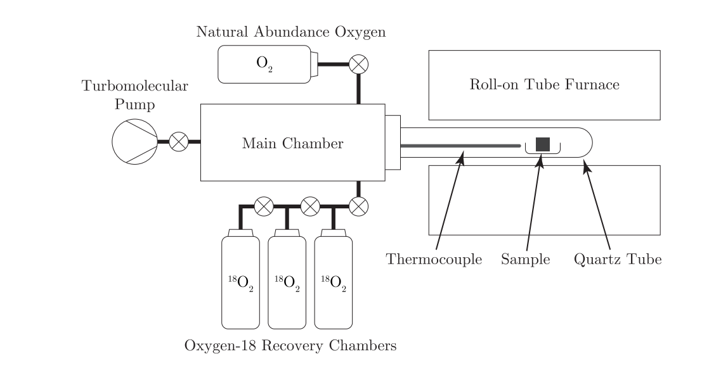

Fig. : Illustration of a dry oxygen exchange rig.54

To ensure that the concentration of gas species from the pre-anneal is minimised, the quatz tube is pumped down to a pressure of 10-9 bar. The second stage involves annealing the sample in an isotopically enriched exchange environment which is performed at the same gas pressure and temperature as the pre-anneal, but for a shorter time (Dry: 90% 18O2 and Wet: 99.9% D2O or 97% H218O). In order to obtain an accurate and well fitted concentration profile, the sample must be at the target temperature for as long as possible with minimal time spent heating and cooling. For this reason, the quatz tube holding the sample is slid in and out of the furnace (Fig. 10).

## Secondary Ion Mass Spectroscopy (SIMS)

Time-of-flight (ToF) SIMS (Ion-ToF GMbH, Germany) was used for all SIMS measurements in this report. Because of the fast-diffusive properties of oxygen in CGO10, the sample was analysed using the line scan mode. The sample was sectioned perpendicular to the exchange surface, before being ground and polished following the same procedure detailed in Section 8.4. To prevent distortions in the ion beam’s electric field, the samples were glued together to eliminate edge effects. The ToF-SIMS was operated with a pulsed dual beam mode using Cs+ as the sputtering source and Bi+ as the analysis source. Due to the low electronic conductivity of CGO10 at room temperature, an electron flood gun was used to dissipate the surface charge generated by the ion gun.

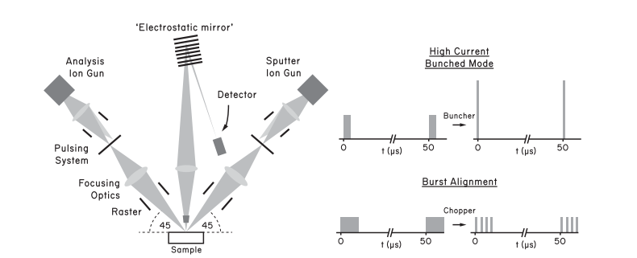

Fig. : Illustration of a ToF-SIMS set-up (left) and the two main beam modes(right).55

The secondary ion yield is defined as:

|  |  |  |
| --- | --- | --- |
|  |  |  |

where is the secondary ion current of species *i*, is the primary ion current, is the sputter yield, is the ionisation probability, is the concentration fraction of *i* the surface layer and η describes the ion efficiency of the analysis system. Ionisation probability is dependent on the matrix of atoms surrounding *i*, better known as the matrix effect.

The ToF-SIMS works on the principle that heavier atoms will travel slower than lighter atoms at equal kinetic energy. Therefore, charged particles travelling a known distance will have flight times proportional to the mass to charge ratio. This process is illustrated in Fig. 11 (left). The primary ion has two working modes, high current bunch mode and burst alignment (Fig. 11 right). Bunch mode condenses a 20 ns pulse into a 0.6 ns pulse, thus increasing the primary ion current. The short pulse increases the mass resolution by reducing the flight time distribution, while the increased primary ion current enhances the secondary ion current (Eq.70). Burst alignment works differently and chops a 100 ns pulse into several 1 ns pulses. This mode significantly reduces the secondary ion current per pulse but is vital in reducing saturation of the detector when analysing species with high ionisation rates.43

## Concentration Profile Acquisition, Treatment and Fitting

Depending on the diffusion length (), one of two SIMS methods is appropriate. For diffusion lengths below 10 µm, the exchange surface can be directly sputtered using a raster gun, this is known as depth profiling. Although sample preparation is simple, the diffusion length is limited due to the time taken to mill the surface. Therefore, for larger diffuison lengths (> 50 µm), line scan analysis is used instead. In this case the sample is cut normal to the exchange surface, glued face-to-face and polished to a 0.25 µm surface finish (Fig. 12). The SIMS instrument takes an image of the cross section where the pixels represents the tracer concentration profile.

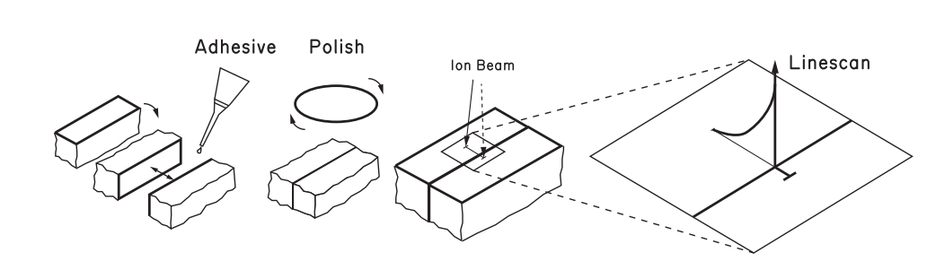

Fig. : Illustration of sample preparation for line scan samples showing the resulting concentration profile from a line-scan.55

In both SIMS methods, the isotopic fraction () is determined by normalising the intensity of the secondary ion For tracer oxide diffusion analysis, the 18O- (*m/z* = 17.999) secondary ion peak was traced, and the isotopic fraction calculated, according to:

|  |  |  |
| --- | --- | --- |
|  |  |  |

where *I* represents the intensity of the secondary ion collected. For proton diffusion analysis, the OD- (*m/z* = 18.009) secondary ion peak is traced instead of D- as it has been reported to have a greater relative intensity.53 To calculate the tracer exchange and diffusion coefficients from the SIMS data, the isotopic fraction must be normalised to account for the absolute concentration of the isotopically enriched gas and the isotope concentration of the sample after the pre-anneal according to:

|  |  |  |
| --- | --- | --- |
|  |  |  |

where is the background isotope fraction and is the concentration of the isotope enriched gas species. As discussed in Section 0, the concentration profile for a sorption problem must be fitted with a complementary error function to extract the diffusion coefficient. To find the exchange coefficient, Cranks solution to the 1D diffusion equation in a semi-infinite domain is used:

|  |  |  |  |  |
| --- | --- | --- | --- | --- |
|  |  |  |  |  |
|  |  |  |  |  |
|  |  |  |  |  |

|  |  |  |
| --- | --- | --- |
|  |  |  |

Fig. 13 is an example of a SIMS images taken at 1080 pixel resolution after an isothermal isotopic exchange. Image data were aligned using the MatLab app TraceX and the concentration profile was plotted and fitted using the Python library scipy.optimize.curve_fit.

Fig. : Example of a SIMS image for tracer diffusion concentration profile using SIMS (CGO10 dry oxygen exchange at 600 ˚C for 60 minutes).

Illustrated in Fig. 14 is an example concentration profile of 18O diffusing normal to a sample surface extracted using SIMS. The scatter between points is low and the fitting is well aligned. Near to the surface of the sample there is a drop in the 18O concentration. This is observed only in line scan mode near to the edge of the sample where the total secondary ion count drops considerably. For samples in which the exchange coefficient is far lower than the diffusion coefficient (difference of approximately 4 orders of magnitude), the concentration of tracer ions is low and so there is considerably more scatter in the SIMS data.



Fig. : Example tracer diffusion concentration profile using SIMS (CGO10 with 3nm sputter Pt surface dry oxygen exchange at 600 ˚C for 60 minutes, ( = 3.73 x 10-8 cm2 s-1 and = 4.22 x 10-5 cm2s-1).

|  |  |  |
| --- | --- | --- |
|  |  |  |